SkillsUSA Membership & Conference Registration Web Site User’s Guide

Revised: Oct-2015

**Contents**

How do I log in to the site? 2

How do I create a Login for myself? 2

What if my school isn’t listed? 3

Ok – I got logged in. Now how does the system work? 4

*What does Submitted and NOT Submitted mean?* 4

Membership Registration 4

Completing your Rosters online is simple – just follow these three basic steps: 4

Adding Members 5

Step 1: Create / Verify Training Programs 5

Step 2: Enter Individual Information on Students and Advisors 6

Step 3: Join! 7

Frequently Asked Questions About Membership 9

What If We Have a New Advisor This Year - Should We Create a New Training Program? 9

How Can I Get a Copy of the Invoice Showing My Total Dues? 9

Can I Pay Membership Dues By Credit Card? 10

How Do I Delete One or Two Students or Professionals? 10

How Can I Find a Member – I Forgot Which Training Program I Put Her In? 10

How Can I Determine Whether I Entered a Member Twice? 10

How Do I Change My School Address? 11

How Can I Get a Complete School Summary Invoice? 11

Can I Submit One Training Program Multiple Times, for example, Fall and Spring? 12

Is There a Way to Export Membership to Excel? 12

Can I Upload All My Members Using An Excel Template? 12

Conference Registration 13

How Do I Start the Conference Registration Process? 13

Where are the Conference Registration Details? 14

How Do I Choose a Contest for a Contestant? 15

Entering State-Specific Information, Optional Product Fees and Payments 16

Submitting Conference Registrations 17

Fee Summary, Fee Detail and Registration Summary Reports 18

Fee Summary 18

Registration Summary 18

Frequently Asked Questions About Conference 18

When I add Optional State Products, they seem to disappear? 18

How can I find my Conference Invoice again? 19

I already clicked to submit my Conference registrants, but need to change something – can I go back and “unsubmit” to make changes? 19

How do I log in to the site?

Go to the registration web site is at [www.skillsusa-register.org](http://www.skillsusa-register.org) and click the link to Login. Enter your login name, which should be your email address, and password, then click Login. Of course, the first time you access the site, you will not have a login account yet, and will need to create one for yourself. Once you’ve logged in, advisors can ONLY enter and edit membership registrations for people from their school – they cannot see or edit information from other schools. Only the State Director has the ability to see and edit information statewide.

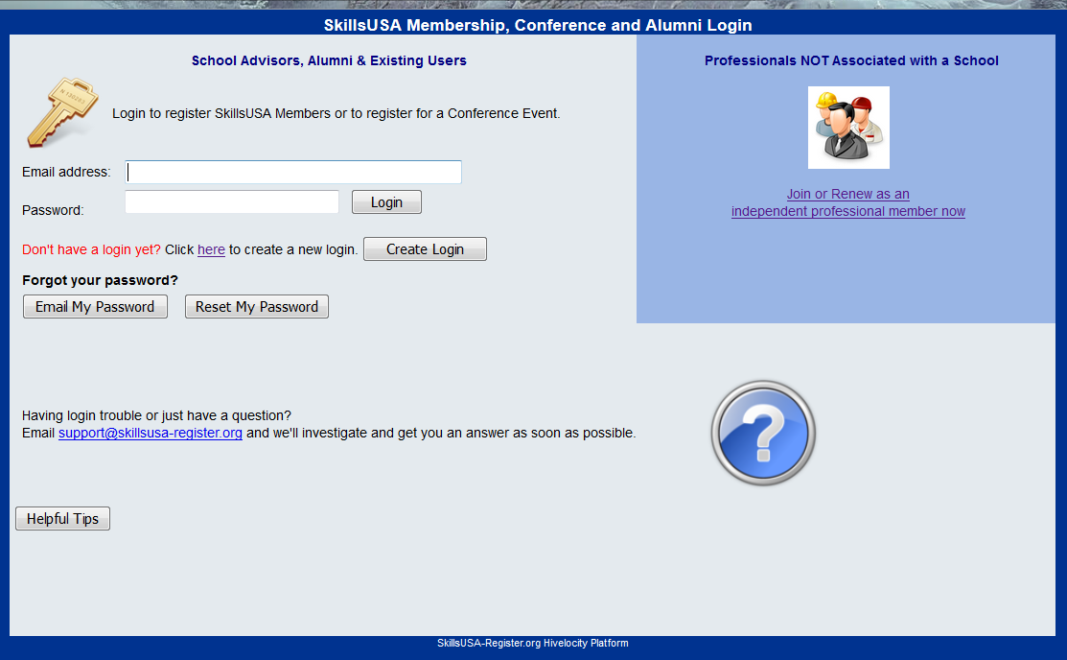

How do I create a Login for myself?

The first time you access the SkillsUSA Registration web site, you will need to create a login for yourself. From the Login Page, click the Create Login button. On the following page, follow along as a wizard prompts you to select your state and school, and then supply a valid email address, provide a password of your choosing, and then supply a personal question/answer for a password hint, in case you ever forget your password.

If yours is a ‘split’ state, with separate Secondary and PostSecondary SkillsUSA offices, be sure to select the correct state association record to populate the appropriate list of available schools.

Create Login Wizard Step 1

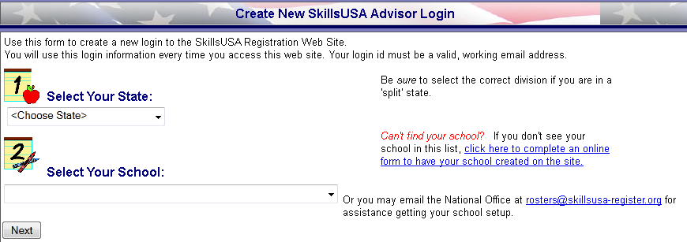

Create Login Wizard Step 2

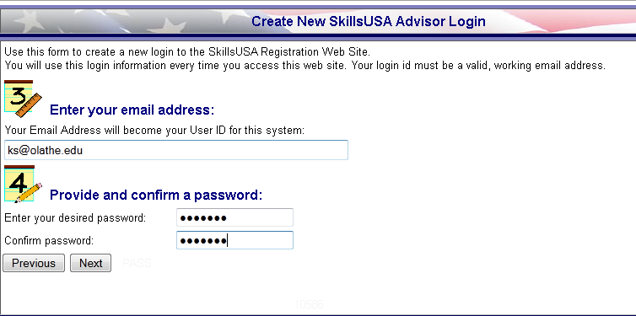

Create Login Wizard Step 3

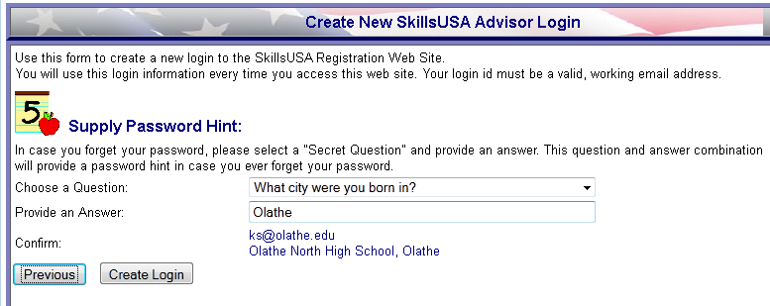

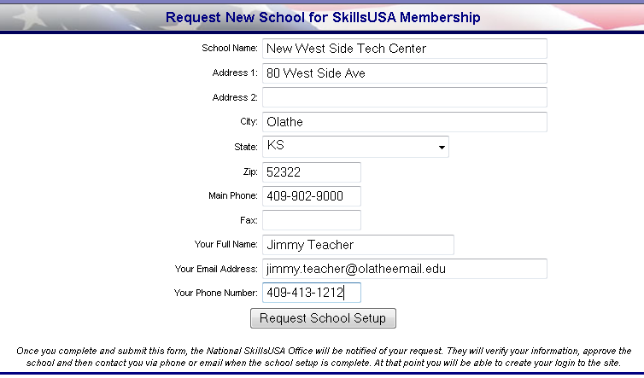What if my school isn’t listed?

The web site database is populated with all the schools and training programs that were active in the past year. If yours is a new school, or you have not been active in a number of years, then your school may not appear in the list. Please look very carefully for your school, checking for differences in spelling or abbreviation. Once you’re certain your school does not exist in the database, you can click the link on the very first page of the Create Login process to create your new school, and then fill out the information in the form as shown below. Once you complete this form, the National Office Staff will verify your school information and then approve the school so you can create your login.

Remember – submitting a request for a new school notifies the National Office Membership Staff that you want your school approved – it can take up to 48 hours for the National Office staff to verify and approve your school. Please wait for an approval email before trying to create your login again.

Ok – I got logged in. Now how does the system work?

Once you are logged into the system, there is a menu bar at the top of the page with common functions you will need to use. The Membership menu contains items related to registering your SkillsUSA members, while the Conference menu contains items related to registering for a competition or leadership event or Conference. Using the Membership system is described below, while the Conference Registration system is described in more detail starting on page 13.

The main “landing page” of the site shown below illustrates the top level menu, a brief snapshot of your Membership statistics so far on the left side and Conference statistics on the right.

### What does Submitted and NOT Submitted mean?

*Notice in the sample screen shot below that this School has 33 Submitted Members and 68 individuals who have been keyed into the site but who have not yet officially “joined” SkillsUSA. As you enter students and professionals they are saved on the site, but don’t actually “join” until you are ready to submit an entire training program. See more information on the Membership Submit process below.*

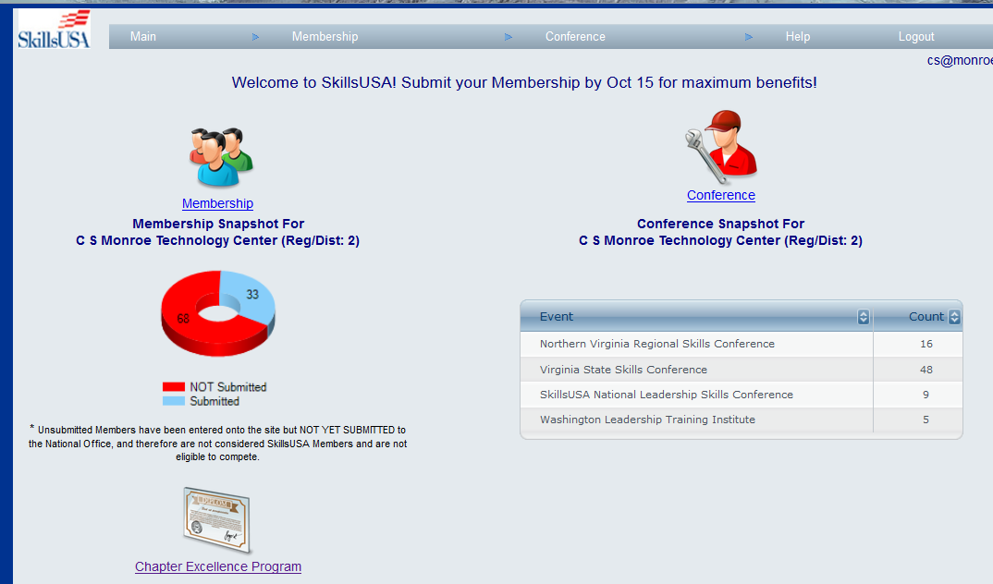

# Membership Registration

Completing your Rosters online is simple – just follow these three basic steps:

1. Create as many Training Programs as you need – these are the classes your students are enrolled in.
2. Enter details about each individual student and professional who wants to join SkillsUSA.
3. Submit each Training Program to officially send the data to the National Office and generate an invoice.

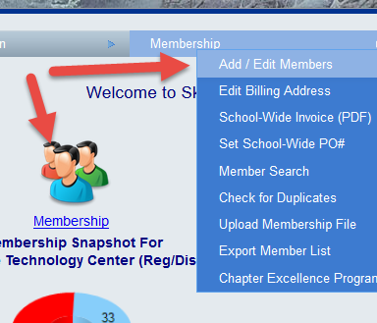

## Adding Members

Either click the Membership icon / link on the main landing page, or use the Membership Menu and click “Add/Edit Members” to begin entering your training programs and new members.

### Step 1: Create / Verify Training Programs

Assuming your school has had SkillsUSA members in years past, you will see a table of all the Training Programs, or classes, that your school has joined before. You can add individual students and professionals into any of these existing Training Programs, or add new Training Programs.

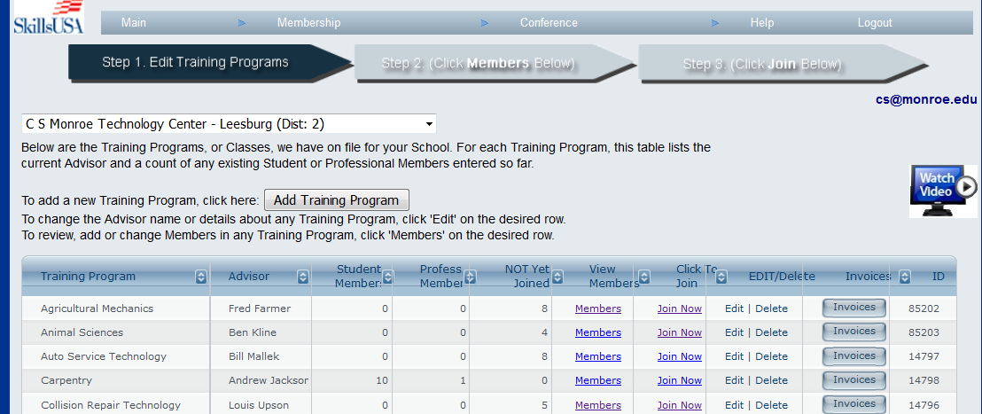

In this example, the school already has several Training Programs with SkillsUSA members in years past. If the school is adding a new Esthetics program this year, click the “Add Training Program” button, or click “Add New” at the bottom of the table, which will display the following pop-up form for entering details about the new Training Program (in this screen shot, we have already filled in the appropriate information for the new Esthetics class).

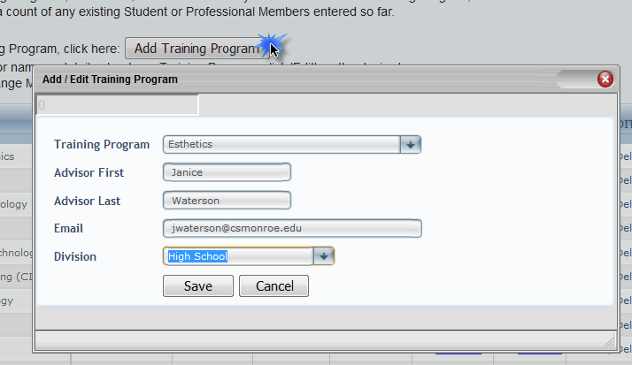

After saving the new Esthetics Training Program, it will be available for editing or for adding members to. Just keep adding Training Programs in this manner until all the SkillsUSA classes you wish to join are entered onto the site and visible in this table – then you’re ready for step 2!

### Step 2: Enter Individual Information on Students and Advisors

To enter all the Esthetics student and professional members, click the “Members” link on that row in the table, which will display the following page with an empty table of individuals.

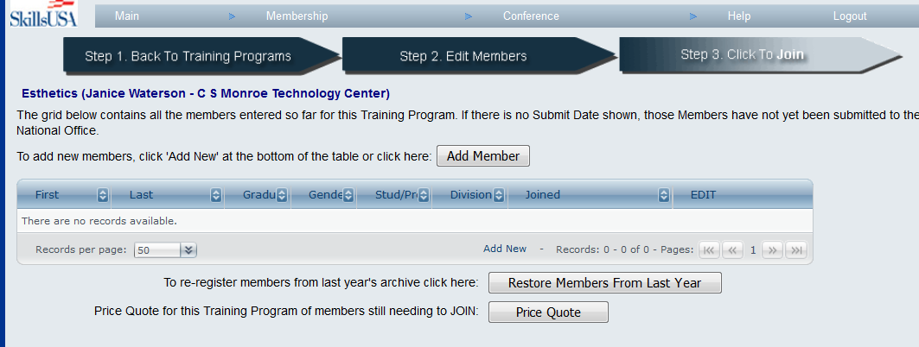

Click the “Add Member” button, or use the “Add New” link in the table footer to start entering individuals using the pop-up form shown below. SkillsUSA strongly recommends that the Advisor (Janice Waterson in this example) be entered as a Professional, so she joins SkillsUSA along with the students. It is important to remember that in order for Janice to actually JOIN SkillsUSA, she needs to be entered as a Professional – just entering her name on the Training Program as the Advisor does NOT join her as a member. Below, in the left-hand screen shot, we’ve entered Ann as a Professional Member. The right-hand screen shot shows one of the student members, Wendy Hines, being entered.

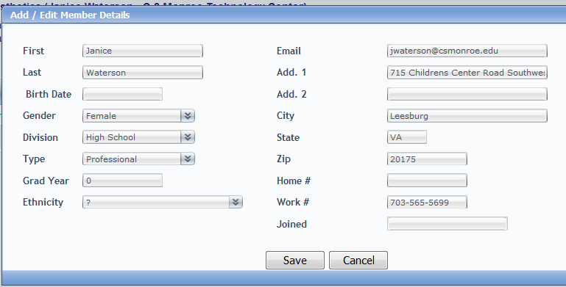

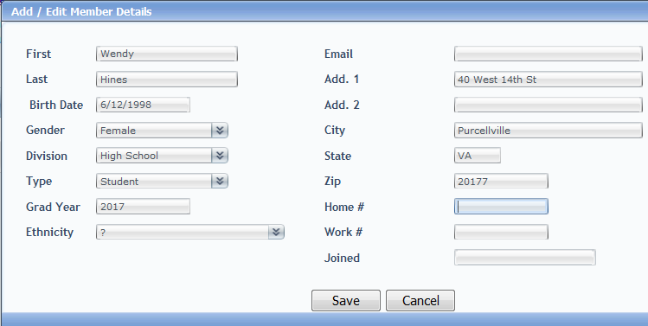

Helpful Tip

*As you add individuals, this pop-up will automatically default to the School address, to save you time in doing data entry. However, if you actually enter each student’s home address, then registering these students for any Conference event on the site is much easier, since the site will automatically carry over the home address. If you just leave the school address, then when registering for a Conference event, no address details will be copied over at all and you will need to enter the home address then.*

#### *Restoring Members From Last Year*

At the beginning of each school year, all the STUDENT Membership details from the prior year are “archived” on the web site – this is to prevent schools from accidentally re-registering a bunch of students that graduated during the next school year. Professionals are NOT archived – they stay listed in the Membership Roster year over year until someone manually removes them. In many cases you will have some Students from the year before come back and want to join SkillsUSA again the next year. You can use the “Restore Members From Last Year” button to bring them back without re-typing all the details. On this page, click the check box in the first column to indicate which individuals are coming back and then click the “Restore Selected Members” button to copy their information for the current year.

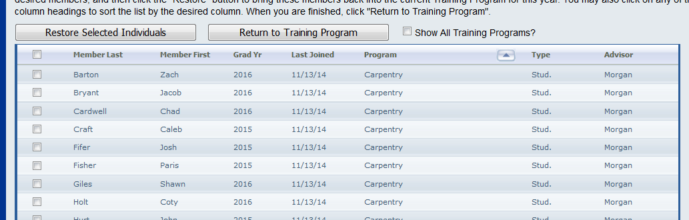

By default this Restore Members page only shows Students from the Training Program you are currently working on, making it easy to restore students into the same program they were in last year. However you can click the “Show All Training Programs” check-box to show ALL former students from all the Training Programs at the school, and thus restore a student who was in the Auto Refinishing Program last year into the Auto Service Tech program this year, for example.

### Step 3: Join!

Once all the individuals have been keyed in, you’re ready to submit the Training Program. If you are still editing the list of Members, you can click the “Step 3. Click to Join” image/button on top; if you’ve gone back on the list of Training Programs, click the “Join Now” link on the desired row to join all the students and professionals in one Training Program.

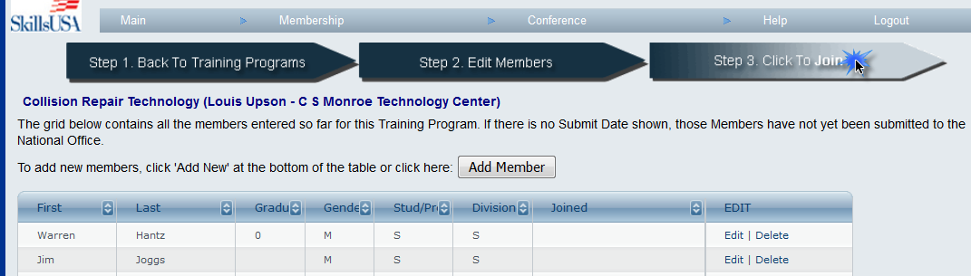

You will be presented with a verification screen like the one below, which summarizes the information on the Training Program you are about to join.

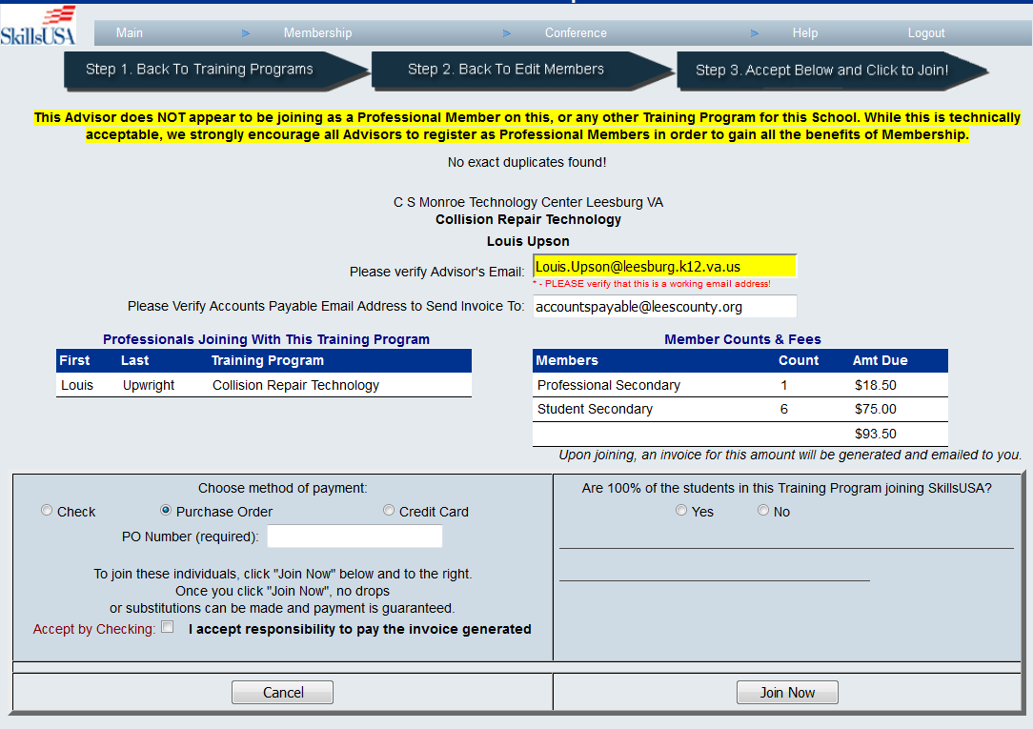

This summary page is full of information, including a summary of the fees anticipated for the Training Program, a list of any potential duplicate members (in case you accidentally entered one student or professional into TWO Training Programs at the same school), and whether or not the Advisor is joining as a Professional Member. You need to indicate how the invoice will be paid, and check the “Accept Responsibility” box indicating you accept responsibility for the invoice generated, and then click the “Join Now” button. (If your school has a Total Participation Plan in effect with the National Office, you will not see the payment options.)

When you click the “Join Button”, several important things happen:

1. All the individual students and professionals in this Training Program become official SkillsUSA members and this list (or roster) is submitted to the National Membership Office. These members will now begin to receive all the material and benefits of being associated with SkillsUSA and are eligible to compete in District, Regional and National Conferences.
2. Unless the school has a campus-wide or Total Participation agreement, an individual invoice is generated for this Training Program, as seen below. This invoice is due and payable immediately – a copy will be emailed to you automatically, and it is your responsibility to submit the invoice to your accounting or administrative office for processing, or to pay it yourself online with a credit card.
3. Since SkillsUSA does not allow drops or substitutions once a Training Program has joined, all these Members also become “read only” on the site – meaning you can no longer go into each individual to change the name or date of birth or anything.
4. The Training Program, and each individual, are stamped with a “Join Date” which indicates the date on which they became official SkillsUSA members. This date can be important for competition eligibility, and you can see it on both the Training Program and Member tables on the site.

That’s it! Once you’ve completed these three steps, your SkillsUSA membership is complete.

# Frequently Asked Questions About Membership

What If We Have a New Advisor This Year - Should We Create a New Training Program?

If you had one Advisor in charge of a Training Program last year, and this year you have a new or different teacher in charge, you DO NOT need to create a new Section. You can just change the Advisor Name and Email address on the Training Program Details page for that particular class. The only time you should create a NEW Training Program is if you decide to offer another class in one particular Training Program, and each Class wants to have it’s own SkillsUSA Section. But in general, if your school typically has one Carpentry class each year, for example, then you can just use that same Carpentry Section each year online, regardless of who the teacher or Advisor is for that year.

Just click the “Edit” link on the row of the Training Program you need to adjust:

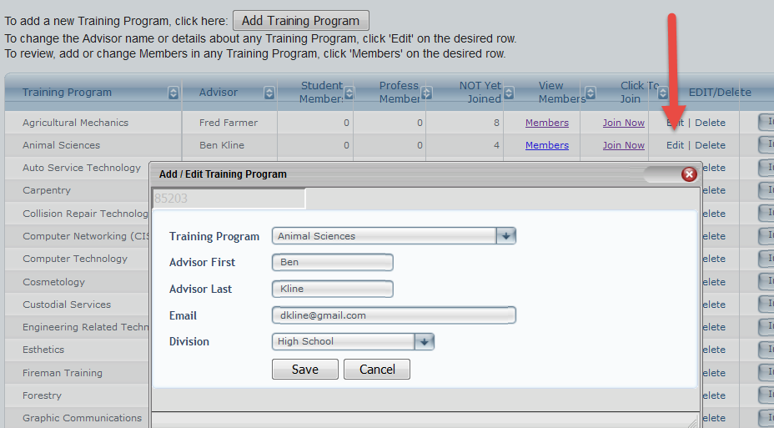

How Can I Get a Copy of the Invoice Showing My Total Dues?

Once you have Submitted each Training Program, the invoice automatically pops up in it’s own window, and a PDF copy is also emailed to both your email address (as the user who submitted it) and to the Accounts Payuable email address you confirm on the Verify Submission page. However, at any point you can go back and review your invoices (even from years past) and reprint them. Just click the Invoices button on the Training Program row you want, and then click the hyperlinked Invoice Number. You can even pay the open invoice by credit card directly from this page.

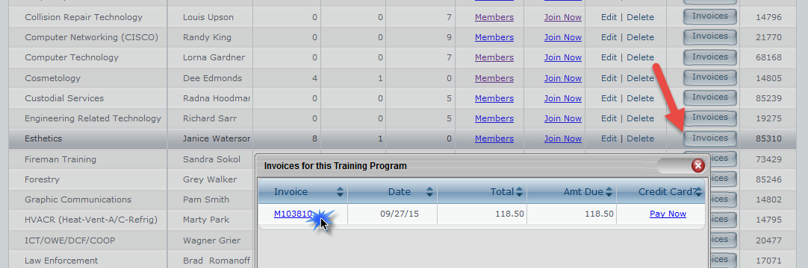

Can I Pay Membership Dues By Credit Card?

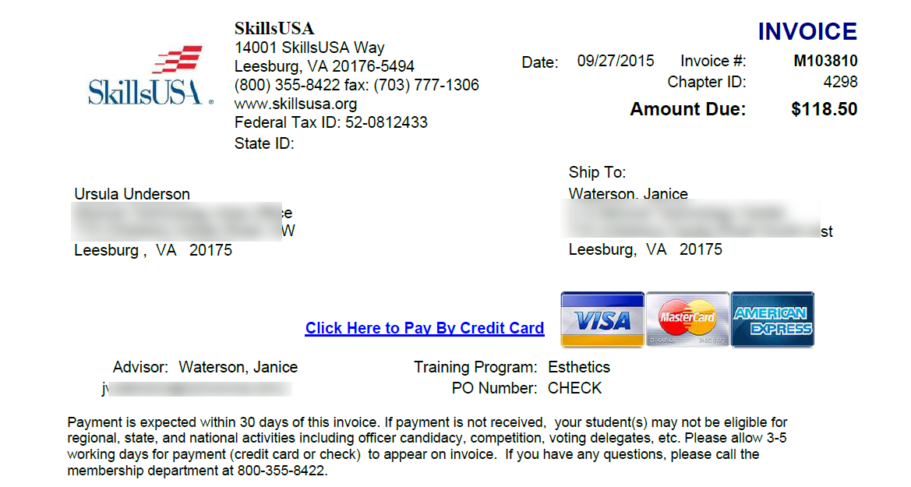In order to submit a Roster to the National Office, you must supply either a PO Number, Check Number, or pay by Credit Card. If you want to pay with a school or personal credit card (VISA or MasterCard), then run the Invoice (as shown above) for whichever invoice you wish to pay, and click the Pay By Credit Card link at the center of the invoice. This process will take you through two additional pages, one to summarize the roster you are going to pay for, and allow you to supply card holder information, and then one further, SSL-Secured screen hosted by the credit card processor for SkillsUSA where you supply your actual VISA or MasterCard information.

How Do I Delete One or Two Students or Professionals?

As long as the members have **not been submitted**, you can delete one or more members from the Edit Members page – just click the Delete link on the far right next to any **unsubmitted** individual, then confirm your choice.

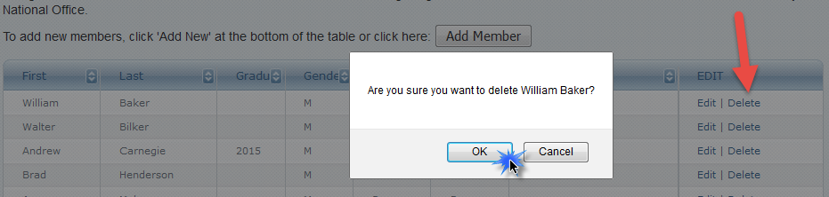

How Can I Find a Member – I Forgot Which Training Program I Put Her In?

Especially with Advisors and other Professional Members, it’s easy to lose track of which Training Program you put them in. For example, if Anne Winters teaches several of your classes, and is listed as the Advisor on multiple Training Programs, you only want to enter her as a Professional Member in ONE of them– but you may forget which one you entered her into. There is a **Member Search** function available on the Membership menu that automatically scans through all your Training Programs and shows you where a member is located. Enter any portion of the member’s first or last name, and click Search to have the system look through the entire School for any matching member names.

How Can I Determine Whether I Entered a Member Twice?

We’ve seen a number of Schools where the Advisor gets entered as a Member in multiple Sections – which means that one person is being charged multiple dues fees. Remember that a teacher can be the Advisor listed on many different Training Programs, but only needs to be listed as a **Professional Member in ONE** Training Program (and it makes no difference which one). Before you submit a Roster to the National Office, it’s a good idea to run the “Check For Dupes” report available on the Membership menu to see if you may have entered the same member more than once. This process does a simple First/Last name match across all your members for the entire school, so it is possible to see two people listed on this report if they have a common name. For example, if you have two male students in your school, both named John Smith, and they are both SkillsUSA members, in different Training Programs, then this report would show them both, but that is not a problem, since they really are two different students. However, if Anne Winters is the Advisor of Cosmetology and Nail Care both, and you accidentally entered her as a Professional member in BOTH Training Programs, that would be a problem, because it’s the same person registered twice (thus paying membership dues twice). This report helps point out this kind of problem. (This “check for duplicates” process automatically happens when you submit each training program, and the Verify Submission page lists any potential duplicates.)

How Do I Change My School Address?

The Registration web site will only allow Advisors to edit / change the Billing Address for your school. You can access this page from the **Membership** menu by choosing **Edit Billing Address**. If the actual physical address of your school has changed, you will need to contact the National Office by emailing [info@skillsusa-register.org](mailto:info@skillsusa-register.org) or by phone at (800) 355-8422.

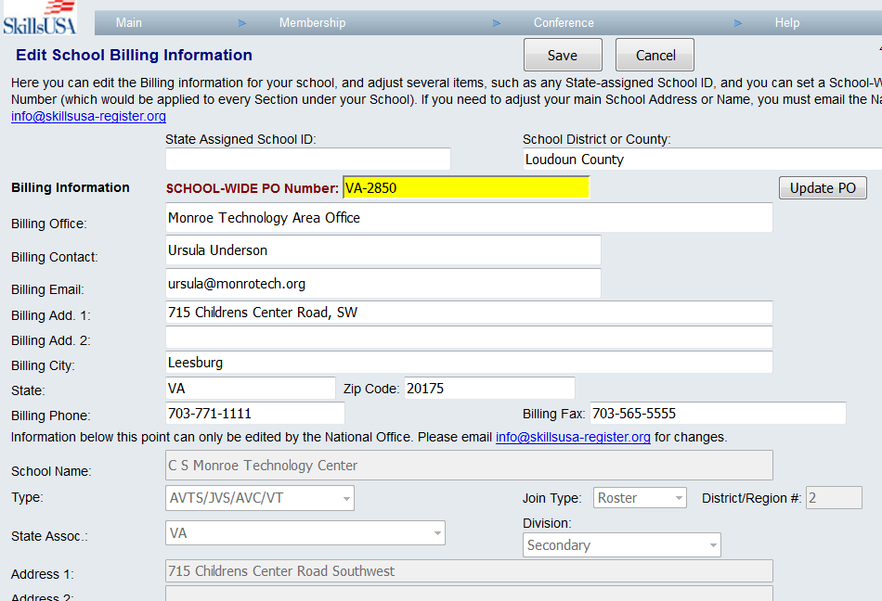

How Can I Get a Complete School Summary Invoice?

In addition to running invoices for each individual Training Program, the web site allows you to generate a School Summary/Invoice that summarizes the members and dues amounts for the entire school. This is especially useful if your school intends to submit one consolidated check for all the various SkillsUSA Sections in the entire school.

To access the school summary/invoice, use the **Membership** menu to access **School-Wide Invoice (PDF).** You can also click the “School-Wide Invoice” button at the bottom, of the list of Training Programs to generate a non-PDF quick version of the invoice.

Can I Submit One Training Program Multiple Times, for example, Fall and Spring?

Many schools want to join a “Fall Roster” of students that start a technical program in September, then join another batch of students once the Spring Semester gets underway. This is completely fine – you can add more students at any time, and each time you go through the “Join” process to submit the Training Program, only the NEW members (who have not already been joined previously) are submitted. You just end up with multiple invoices – one for each batch of joined members.

Is There a Way to Export Membership to Excel?

On the Membership menu there is an option to “Export Membership”, which will export all of your current membership details from the site into an Excel document in a new browser window.

Can I Upload All My Members Using An Excel Template?

If you have less than 25 members to join SkillsUSA, you should just manually enter each member onto the Membership site using the instructions above. However if you have a larger list of members, you might prefer to create an Excel file of all your members and have that file uploaded to the SkillsUSA Membership site. This is especially true if your school system has an existing database system that makes it easy to export and manipulate Excel files of student information. There are detailed instructions on the website for how to configure your Training Programs in preparation for the Excel Upload feature, along with a training video you can watch to see how the process works. You can find those instructions (summarized below) on the site under Membership 🡪 Upload Membership File.

|  |  |
| --- | --- |
| **1.** | Make sure your Training Programs are all created on the site. Use Membership 🡪 Add/Edit Members on the menu, and ensure that all your Training Programs are created there. Also, it’s easiest if you go ahead and enter details about your Advisors and any other Professional Members online at this time.   If you have existing Student members in your Section already, they will NOT be overwritten by this upload process. You only need to include NEW Student members as you fill in the Excel file, as any existing members already on the site will remain. |
| **2.** | Click the "Create Excel" button on the Upload Membership page of the site to generate an Excel template file you can use to fill in details about all your membership. **Be sure to save this file as an Excel file** somewhere on your local PC so you can open and edit it. You must use File 🡪 Save AS and be sure to save the file as a Microsoft Excel file (any version), since your browser may try to save this as an HTML file by default, which will not work. |
| **3.** | Open that saved Excel template file and insert/paste/load data on each of your Members. Simply replace the existing place-holder rows with valid data about your actual students. Be sure to leave the first FOUR (4) columns intact, as they contain the ID Number and name for your School and each of your Training Programs. If you have an Excel file in any other format, we CANNOT load it. |
| **4.** | Once you have completed your Excel file, click “Browse…” to locate you completed Excel file, then use the “2. Upload File” button to load those members to the site. You will receive a Success or Failure message right away, depending on whether the system was able to map your data correctly. |

# Conference Registration

This site handles registrations for the National Leadership and Skills Conference, as well as for many different State and Regional conference events. You will need to check with your State Director to see if they are using this site for your particular State Conferences.

*Note – While ALL Schools must submit the SkillsUSA Membership on this National website, there are several other options for states to handle their own Conference registrations, so be sure to check with your State Director if you are unsure where to register for your state events.*

How Do I Start the Conference Registration Process?

When you click the **Conference 🡪 My Registrations** menu, the following page appears. The grid on this page contains a high-level view of the information about each registered participant from your state, including the Name, School, Contest, Division and Team information.

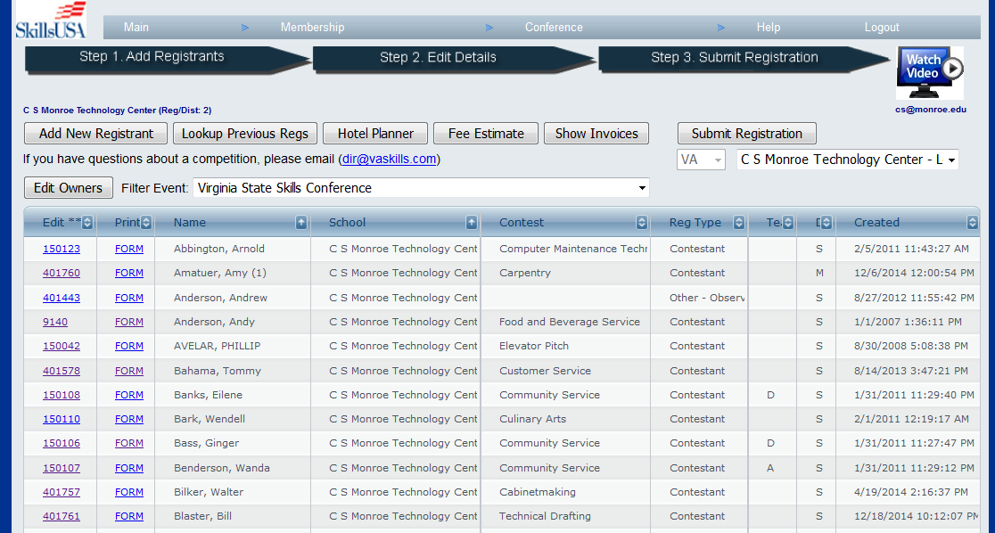

While browsing through the registrants on this page, there are several useful navigation controls you may find helpful. Each of the column headings is a hyperlink you can click on to resort the table by that column. By default the registrants are listed in alphabetical order by last name, but if you’d rather see them sorted by School or Contest, just click the desired column heading to resort.

To add a new Conference Registrant, click the Add New Registrant button, which will open another page where you can fill in the Registrant details. To edit an existing registration, click the unique ID number in the Edit column of the grid. In either case, the following page is presented, which displays the basic demographic information required for a Conference registration.

If you are using the site for your own State Competition or a Regional Conference (in addition to the NLSC competition) then you and your advisors need to pay close attention to the “Filter Event” drop down list. Using this list, you can select the National Leadership Skills Conference attendees, or only your State Conference attendees. When you add a New Registrant, the system automatically assumes they are registering for the selected Event in this list. Be aware that Contest Numbers are different between the State competitions and the National competition. So if you accidentally register a competitor for Welding, but you choose the State Competition, that registration record will NOT be reflected in the National Competition database that is used for National events.

**Double-check all your registrants to make sure your advisors have selected the correct Event!**

Once you have filled in details about your individual conference attendees, you can click the **FORM** link in the registrant table to preview and print a complete NLSC1 Release form for parent / guardian signature.

Where are the Conference Registration Details?

Clicking the ID number in the first “Edit *” column in the table will open the following page, which allows you to add or edit Registrant Details, such as home address, parent’s names, and contest information.

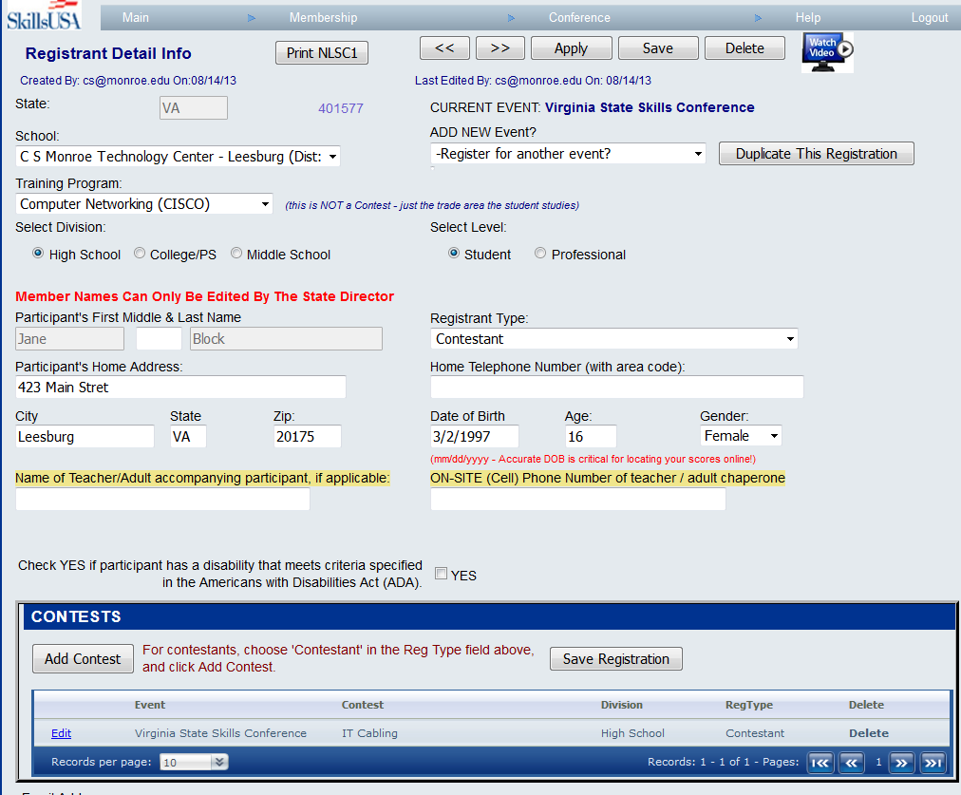

This page is fairly self-explanatory, but there are a few important details to remember. **Be sure to** **enter the names of your Competitors in Upper and Lower Case (proper noun) format, as we will print name badges and display winners during the Award Ceremony using the data exactly as you enter it here.**  Home address information is required, as is Date of Birth, Gender and Shirt Size (for most Conference Events).

It is important to supply age and date of birth information for students and competitors, but not necessarily for professionals and other adult registrants. If Competition Scores are posted on this web site (for the National event or any State Event), the student will need to supply their Contestant Number AND their Date of Birth in order to retrieve their personal scores. If you enter an incorrect birth date now, they will never be able to find their own scores later.

### How Do I Choose a Contest for a Contestant?

At the bottom of the Registrant Details page, on the Contest tab, there is a button to “Add Contest”. Click this to select which Contest a Contestant will compete in.

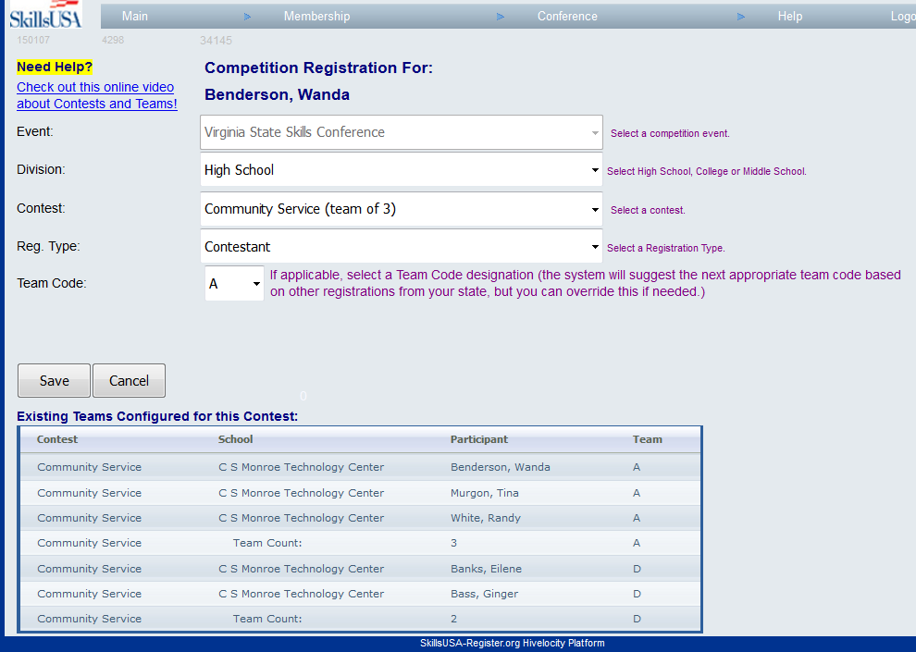

This page allows you to supply the details about what contest a particular student will compete in, and in what capacity they will compete. Just work through these drop down lists in sequence from top to bottom.

The Event list will indicate whichever Event your Contestant is registered for, which will usually be the National Leadership Skills Conference. If your state were using this web site for your State Competition Registrations, then your State Event would also appear in this list.

**It is critically important that you select the correct division for the competitor and contest.**    
Since most contests have both a Secondary and Postsecondary division (and some even a Middle School division), you need to be sure your contestant is registered with the correct group. Each Contest has a unique Contest ID Number internally in the database, and if you register a Secondary contestant for a Postsecondary Contest, this will obviously cause problems at the conference.

#### Understanding Team Codes

For Team events, an additional drop down list will be available for “Team Code”. This is used to group competitors together into teams as required by the particular event. In the example above, this registration is for Opening and Closing Ceremonies, which is considered a Team event. In general, the site will automatically supply the appropriate Team Code value for this field. For the National Event, where each State can only send ONE team in each Contest, then each state and team will get a unique Team Code. For example, the Web Design team from North Carolina could be automatically assigned Team Code A. When Web Design team from Delaware registers online, they might be assigned Team Code G, and each subsequent team from different states gets different alphabetic team codes. Obviously this implies that some very popular events will have Team Codes like AB, or AF. These Team Codes are important to the inner workings of the entire NLSC registration and scoring system, so it is important to understand how these work and enter them correctly.

Entering State-Specific Information, Optional Product Fees and Payments

As you scroll down below the Contest area on the Registrant Details screen, you may see anumber of fields that were added/customized by your State Director specific to your State or Regional Event, as well as areas for you to enter any optional products and to indicate individual payment details. In the screen shot below, there are two specialized state fields – one for # Extra Award Tickets and one for Special Meal Requirements., as well as a check-box question indicating willingness to stay after the event to help with clean-up. Your State Director may or may not have customized similar fields for your Event.

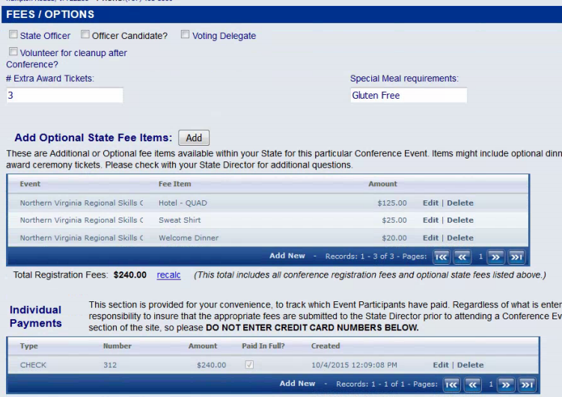

This area also contains two grids for Optional State Fee Items and Individual Payments. If your State Director has configured any Optional Fee items, such as hotel room costs, welcome dinner costs or optional clothing items, you can select or add them to your registration record by clicking the “Add New” button below the State Fee Items grid. Select the desired product from the drop down list and click Save.

Notice the “Total Registration Fees:” section below in the red box – the “recalc” link will recalculate your complete fee structure for each Registrant once optional products have been added. The Payments grid works the same as the State Fee Items grid – just click “Add New” to add a new payment row. This would be used to track each student or professional attendee and how they pay for their conference fees. All these fee items and payment will then appear on the “Fee Detail” report available on the Conference menu.

The Individual Payments grid can be used to enter details about each student’s payments to the local school, and in this way help keep track of who has paid and who hasn’t. In most cases, the School pays the State Office, and the State Office then pays the National Office, but this simple mechanism can help track each student’s individual payment if needed.

### Submitting Conference Registrations

Once you have entered all the students, parents, advisors, etc. that will be attending a Conference Event for your school or training program, you need to “Submit” those Conference Registrations to let your State Director know who will be coming to the event. This is very similar to submitting Membership, in that you will see a summary page and have a chance to verify the results before finalizing and creating an invoice. Click the “Submit Registration” button above and to the right of your list of registrants to view and confirm one of the following invoicing options:

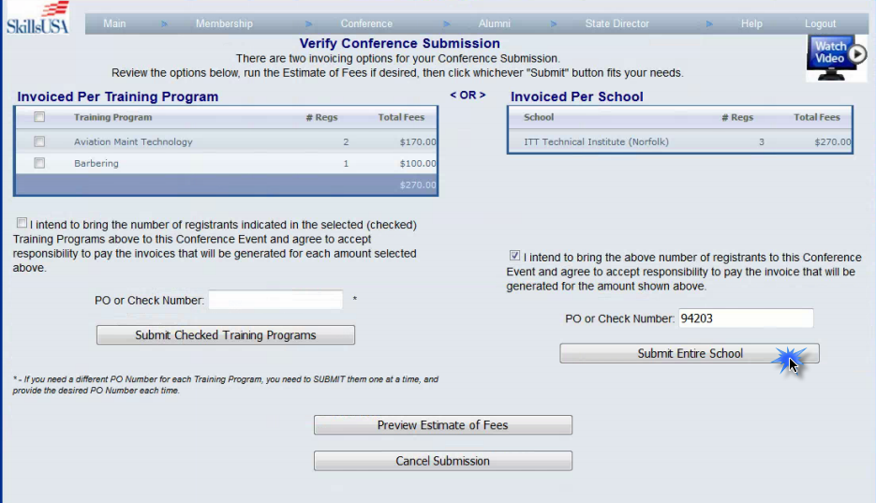

When you submit conference registrations, you can choose to receive either ONE invoice for the Entire School, or distinct invoices for each Training Program. In the screen shot above, there are three people registered from this school, two from the Aviation Maintenance program, and one from the Barbering program. In this example, the user has provided a PO or Check number and accepted responsibility to pay for ONE invoice for the entire school. Once they click Submit Entire School, a new PDF invoice will pop up and the user will receive a confirmation that the invoice was successful and all the registrants are submitted.

Note – Your State Director controls whether or not your particular Conference Event will generate an invoice upon Submission or not. So you may not see this screen at all, if your State Directors does not need invoices for your Event. In that case, clicking the “Submit Registrations” button will just fire off an email to the State Director letting them know you are finished.

Fee Summary, Fee Detail and Registration Summary Reports

The Advisors for each school can easily run Fee Summary, Fee Detail and Registration Summary reports from the site. Click either of these report options on the Conference drop down menu to run the reports.

Fee Summary

The Fee Summary report will calculate the amount your Students and Advisors need to submit to your STATE office. Each State Director can configure the fees per Student and Professional on their State Director pages. This report will only list each attendee ONE TIME, regardless of how many Contests they are registered for (at a State Conference, for example).

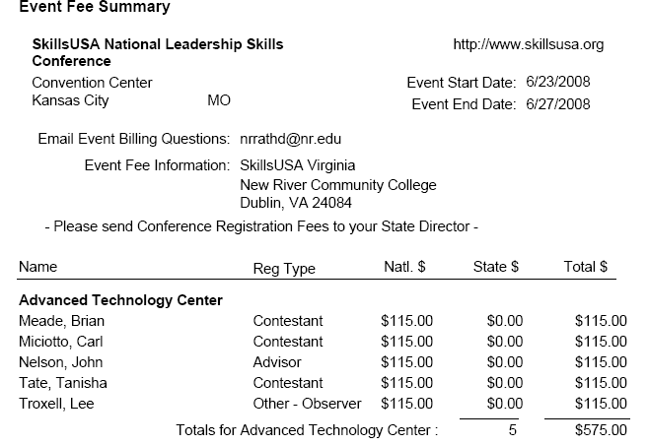

Registration Summary

The Registration Summary report will illustrate every Conference Attendee along with the details about what Contests each competitor is in. At a State Conference, this will likely show the same person multiple times, if that person is registered for several Contests.

Both of these summary reports provide a great way for your advisors to double check their attendee information, to make sure that people are in the right Contests, in the correct Divisions and name spelling is accurate. Remember that whatever spelling and character case is entered on the web site WILL BE USED for name badges and winner details during the award ceremony.

# Frequently Asked Questions About Conference

When I add Optional State Products, they seem to disappear?

When you add a row to either the Product grid, or the Individual Payments grid, you need to be sure to click SAVE each time. Make your selection then look in the footer of the grid for a little “Save” link.

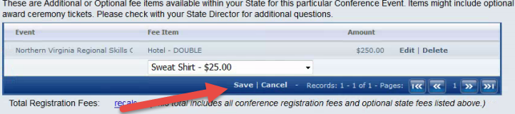

How can I find my Conference Invoice again?

Once you’ve submitted your Conference Registrations, you can click the “Show Invoices” button to see a list of each Conference invoice related to your School. Click the hyperlink to the specific Invoice Number in the first column to open the PDF for any desired invoice. Your State Director has also customized this top area to show any specific instructions for how and where to may conference payments.

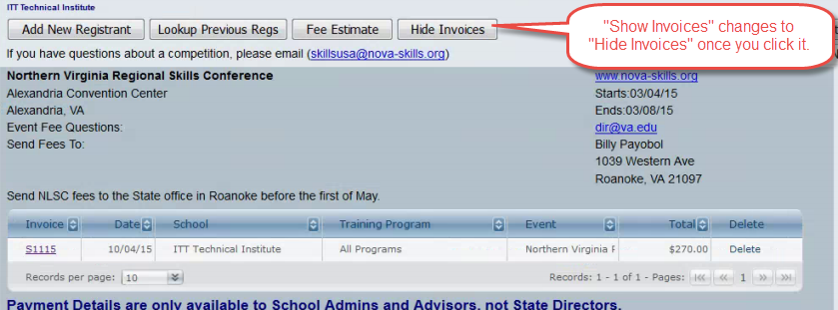

I already clicked to submit my Conference registrants, but need to change something – can I go back and “unsubmit” to make changes?

If you notice you forgot to add some people to your registration list before submitting, or you see on the invoice that you forgot to add some optional State Products, you can use the grid of invoices shown above to delete any invoice just by clicking the “Delete” link on the far right. This will do two things:

1. Deletes the invoice completely
2. “Un-Submits” all the registrants that were included on that invoice – so you can go back and make changes, add people or products, then Submit again to generate a completely new invoice.

This user’s guide is frequently updated as the site changes. You can get the latest version here: <http://www.skillsusa-register.org/unsecure/usersguide.pdf>

**Questions? Suggestions? Email** [**support@skillsusa-register.org**](mailto:support@skillsusa-register.org)